Couples Massage

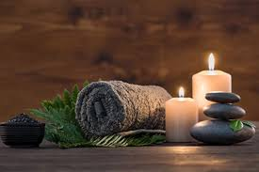
One great way to increase the bond or closeness you feel with your partner is with physical touch. Work, school, kids, mean pharmacy techs, and car troubles tighten up areas of your body. The stress sometimes goes from your head or your emotions, and creates itself a little nest of knots in your muscles. Now, you are tense and sore and in a worse mood than before the tension began. Most likely, your partner feels the same way. A fun and sensual way to unwind is to do a couples massage together.

How to do it:
There are many ways you can do this. Some people want dim lights, candles, and Barry White. Is that cliche? Yes. Is it a little corny? Of course! But both you and your partner will enjoy your time together. You can do it with oils, lotions, or if your shower is big enough, soap and hot water. Flip a coin, heads you massage, tails, your partner starts. Start in big wide circles all over their back and neck. Don’t worry if you are not professional. Allow your partner to guide you to their worst parts and the pressure they appreciate. Talk softly about your day or whatever you want. The point of this exercise is to stimulate the mind and relax. If you wish, you can set a timer and then trade places. Keep doing this until you are both feeling better. It is a nice experience to spice things up, slow things down, and maybe start conversation or a hot bedroom experience!

